**PRESS RELEASE**

**9thSaronic Chamber Music Festival**

**31st - 4th August 2019**

***Αn International Music Meeting on the Saronic Islands!***

The Saronic Chamber Music Festival, now widely acknowledged as an outstanding musical institution, has presented exceptional international musicians combining to perform the core classical chamber music repertoire for nine consecutive years. The ensemble has developed a faithful audience of locals and music lovers from across Europe, attracted by the youthful and committed performances of this passionate ensemble of musical friends.

From July 31st to August 4th world-renowned musicians, including Concertmaster of the Metropolitan Opera, New York, **Benjamin Bowman**, will perform five concerts in the inspirational environs of the Saronic Islands. The repertoire will include major works of **Mozart, Schumann, Dvorak, Schubert, Brahms** and the Greek composer, **Nikos Skalkottas.**

The Festival welcomes **Mr Βowman** for the sixth time along with first time participants**, Αndrew Joyce,** Principal Cello of the New Zealand Symphony Orchestra, and **Kana Sugimura**, an international competition winner and a much in demand chamber musician for festivals around the world.

Regular guest artists of the Saronic Festival include: Finnish violinist, **Sini Simonen,** leader of the *Castalian String Quartet* and the *Calvino Piano Trio;* the Israeli-born pianist, **Noam Greenberg,** one of the UK’s leading chamber music pianists and Artistic Director of *Music Festival at Tresanton*; the cellist, **Julian Arp,** Principal Cello of *O/Modernt* chamber orchestra and Professor of Cello at the *University for Arts in Graz.*

This year's program includes the famous second piano trio of **Franz Schubert,** the masterly but rarely performed Piano Trio No. 3,Op. 110 of **Robert Schumann;** the much-loved String Sextet,Op. 36 of **Johannes Brahms;** the late String Quintet in D of **W.A. Mozart;** the string quartetknown as the "American" by **Antonin Dvorak** and the Duo for Violin and Viola by **Nikos Skalkottas**, honouring 70 years since the composer's death. The program is a celebration of the diversity within the classical repertoire, with concerts that promise to be a nourishing experience for anyone with a small amount of curiosity to attend. This is a Festival that nurtures an informal atmosphere open to all and free to young people under 25 and is an opportunity to hear chamber music at the very highest level.

The 2019 Saronic Chamber Music Festival is made possible by the generous support of the **Embassy of the Federal Republic of Germany in Athens** and receives the full backing of the **municipalities of Hydra, Poros and Trizinias-Methana**. The Hydra series is sponsored by **Mr Hercules Kontos** in memory of his wife, Therese Kontos, a lover of music.

**A note on the Directors:**

The Saronic Chamber Music Festival and the Leondari Ensemble were founded by Greek violinist, Jannis Agraniotis, and Australian violist, Francis Kefford, two musicians who shared a love of the Saronic Islands and a love of chamber music. Jannis currently collaborates with Athens Camerata (Friends of Music Orchestra) and has worked with the Greek National Opera and the Athens State Orchestra. He has appeared in all of the major Greek concert halls as well as in Germany as a recitalist and chamber musician. Francis is a frequent performer with the UK’s leading orchestras, including the London Symphony Orchestra, the Orchestra of the Royal Opera House, Covent Garden, Aurora Orchestra and the Britten Sinfonia.

**Full artist biographies**: [www.saronicfestival.com/artists](http://www.saronicfestival.com/artists)

**FULL FESTIVAL PROGRAMME**

**Wednesday, July 31, 21:00**

**ΜΕΤΗΑΝΑ**

String Quartet in F major, American’,**Op. 96 DVORAK**

String Quintet in D major, K. 593 **MOZART**

**Venue: Open Amphitheatre of Kameni Chora**

**Thursday, August 1, 21:00**

**GALATAS**

Piano Trio No.3 in G minor, Op. 110 **SCHUMANN**

Piano Trio No. 2 in Eb major, D. 929 **SCHUBERT**

**Venue:** **Galatas School**

**Friday, August 2, 21:00**

**POROS**

Duo for Violin and Viola (1938) **SKALKOTTAS**

String Quartet in F major, American, Op. 96 **DVORAK**

String Sextet No. 2 in G major, Op. 36 **BRAHMS**

**Venue: Syggrou Amphitheatre**

**Saturday, August 3, 21:00**

**HYDRA**

Piano Trio No. 2 in Eb major, D. 929 **SCHUBERT**

Duo for Violin and Viola (1938) **SKALKOTTAS**

String Quartet in F major, ‘American’,Op. 96 **DVORAK**

**Venue: Bratsera Hotel**

**Friday, August 4, 21:00**

**HYDRA**

String Quintet in D major, K. 593 **MOZART**

Piano Trio No.3 in G minor, Op. 110 **SCHUMANN**

String Sextet No. 2 in G major, Op. 36 **BRAHMS**

**Venue: Bratsera Hotel**

**INFORMATION**

**TICKETS**

**HYDRA : 10 euro (standard), 30 euro (premium)**

**POROS / METHANA: 10 euro (standard)**

**GALATAS : entry by donation.**

**Young people under 25: free entrance at all concerts**.

**Book your tickets in advance at:** [www.saronicfestival.com/book-tickets](http://www.saronicfestival.com/book-tickets/)

**General info**: [www.saronicfestival.com](http://www.saronicfestival.com/)

[Follow the SCMF on social media](http://www.facebook.com/saronicfestival)**:**

Facebook: [facebook.com/SaronicFestival](http://www.facebook.com/saronicfestival)

Τwitter: [twitter.com/SaronicFestival](http://www.twitter.com/SaronicFestival)

Instagram: [instagram.com/saronicfestival](http://www.instagram.com/saronicfestival)

**WITH THE SUPPORT OF**

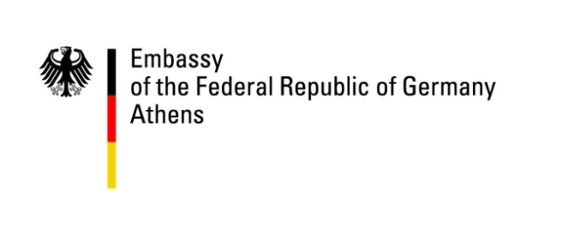

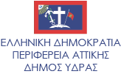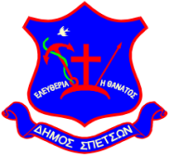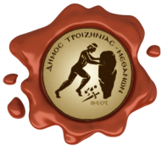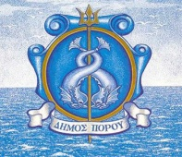 **UNDER THE AUSPICES OF THE MUNICIPALITIES**

**SPONSORS**

C:\Users\Katina\Desktop\SARONIC FESTIVAL\Logos\RaycapLogo.png**C:\Users\Eva\Documents\Φεστιβάλ Σαρωνικού\f.JPG**

**WITH THE KIND SUPPORT OF**

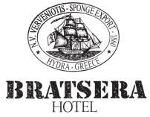

**MEDIA SPONSORS**